Requirements to update the information in TJBFamily.com website.
Home

1. 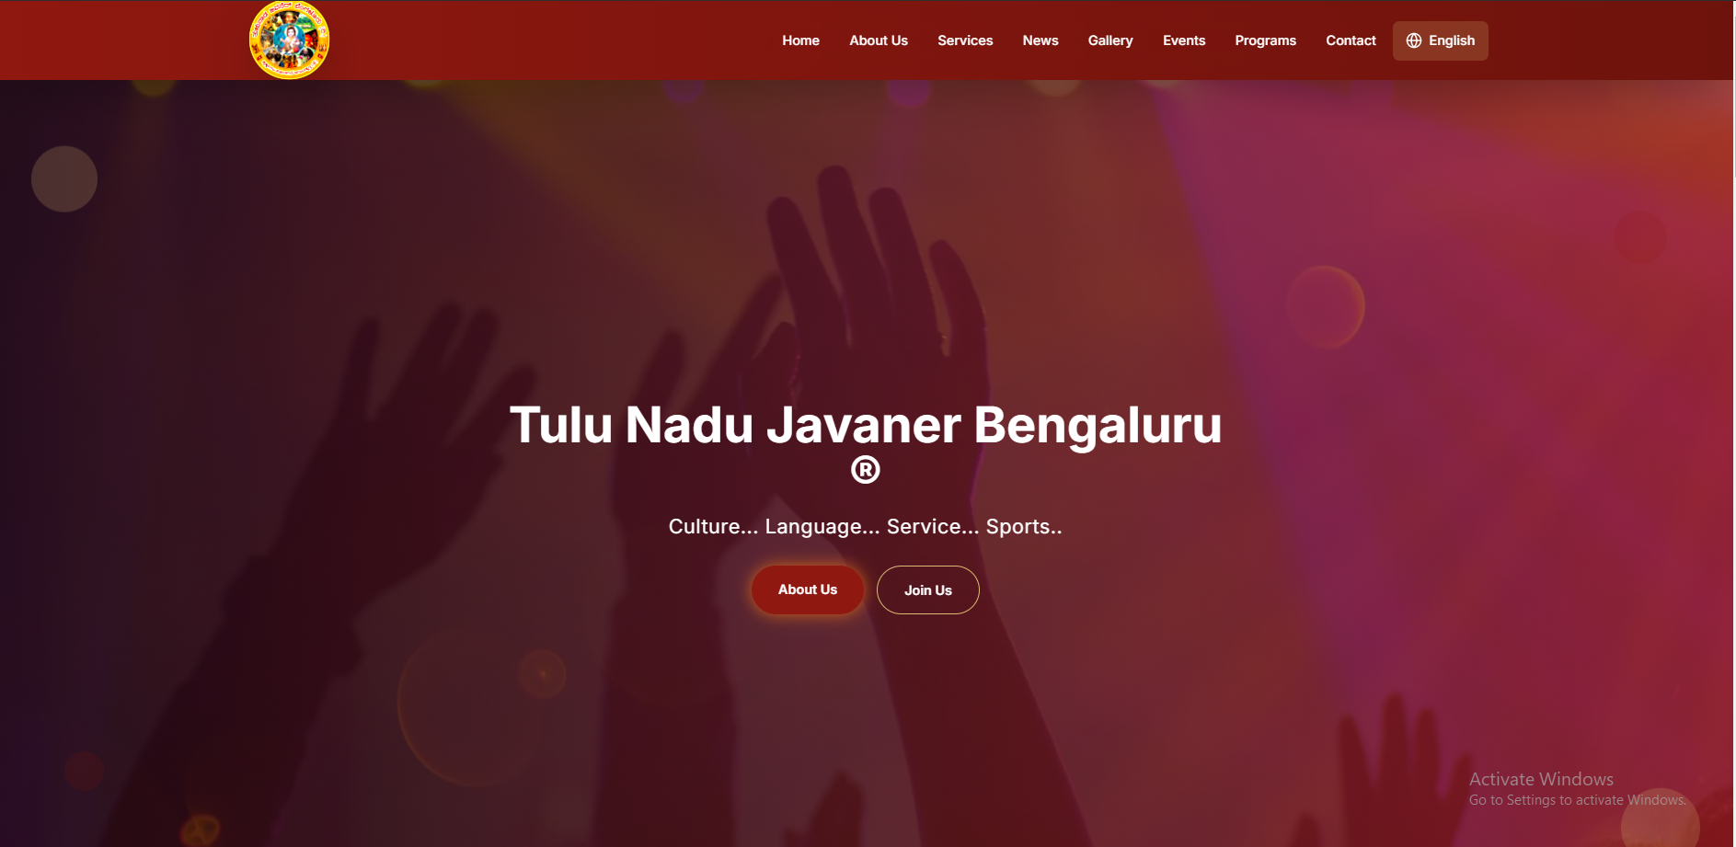
I need about 4 images for a slider where the images will move from right to left. (Optional) Please also provide short content in both English and Kannada to display on those images.
A:
2.
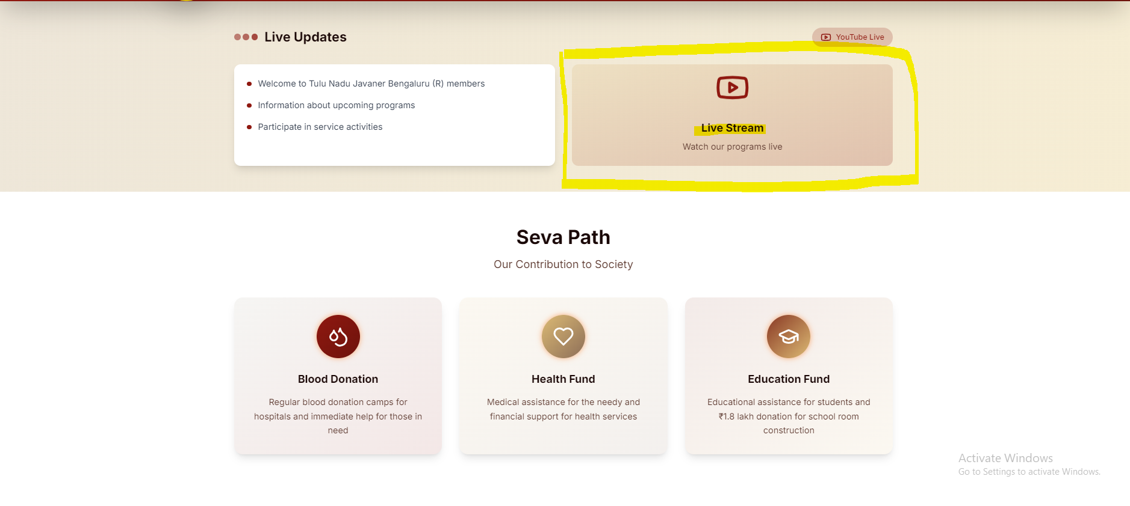
We are providing an option: if any of your events are live-streaming, it will be displayed here.
In Seva Path section, please provide the content both in english and kannada.
Answer:
3. 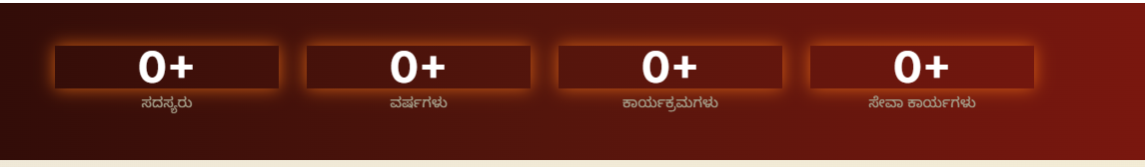
Please provide the count.
Answer:
4. 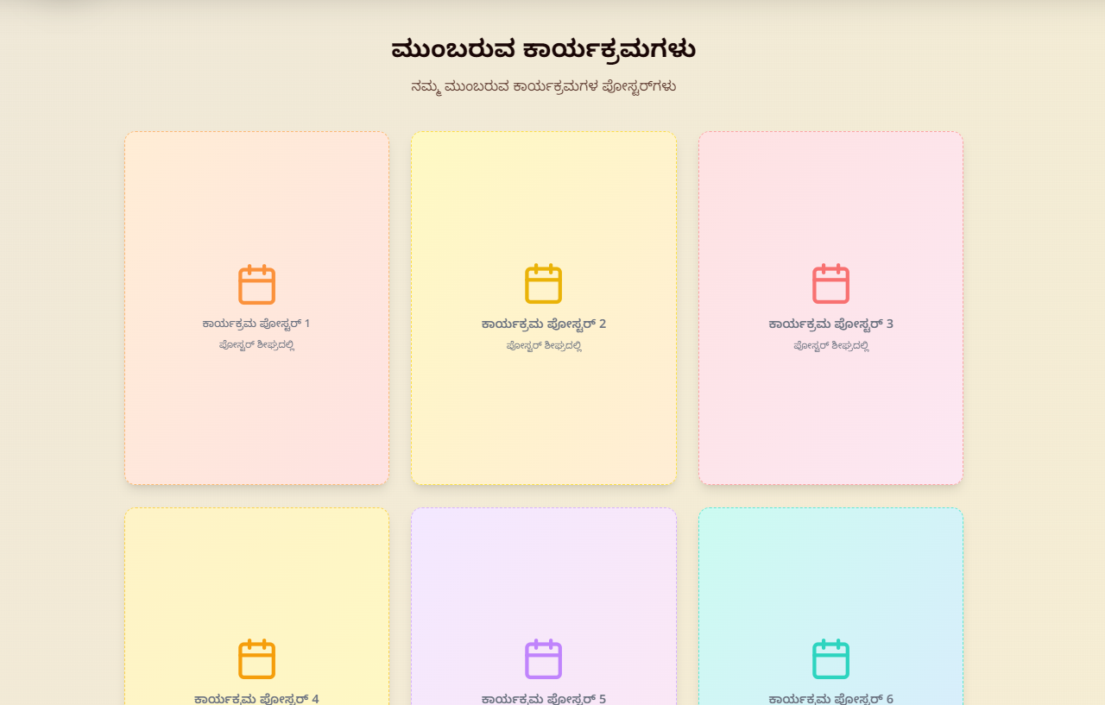
In the Upcoming Events section, we are currently providing space to add event images/posters. Along with the poster, please let us know what details you would like to include. For example, when someone clicks on the poster, it can display detailed information about the event and also provide an option to register.
Answer:

5. 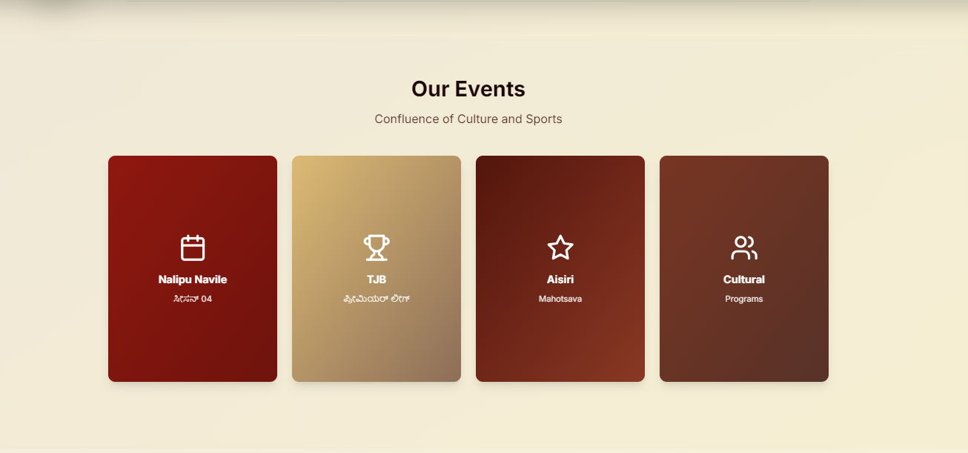
Please provide the images for these.
Answer:
6.
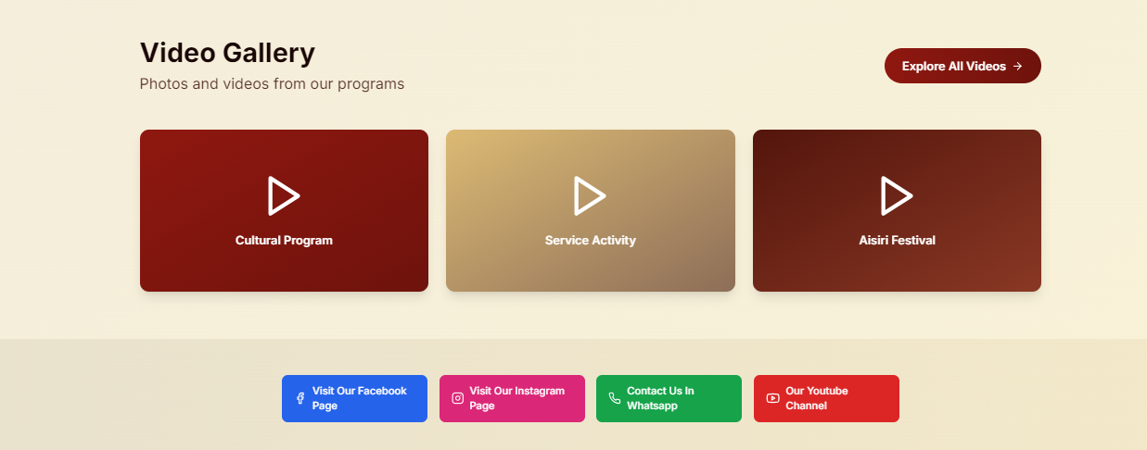
Please provide the video links for these or video in drive.

About section
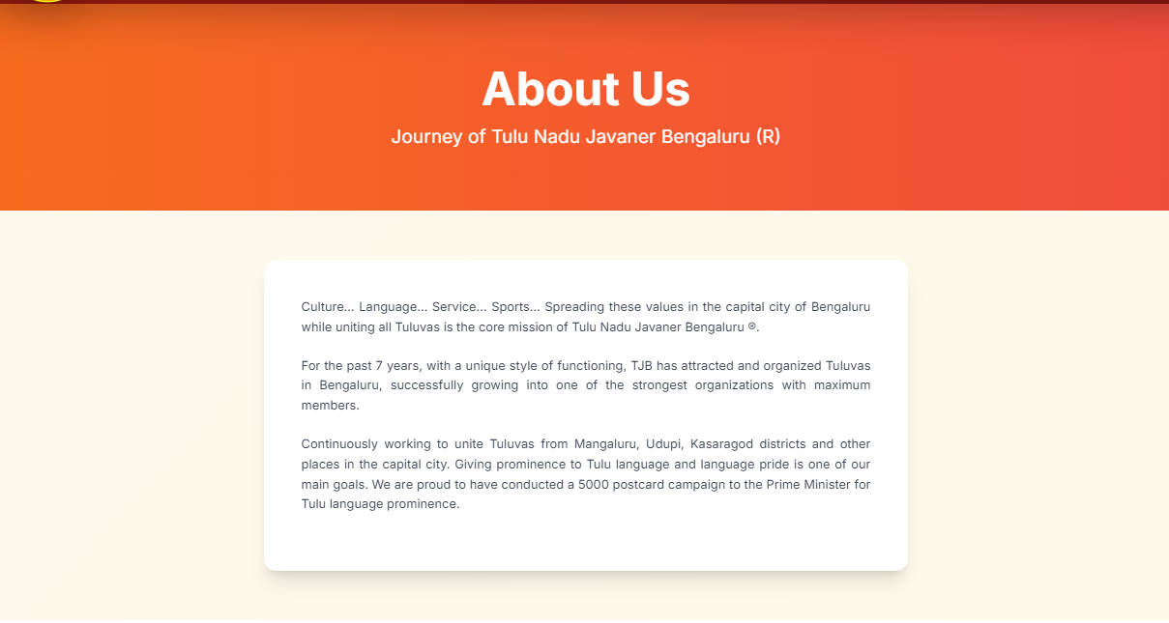
Please provide the content both in kannada and english.
Answer:
2.
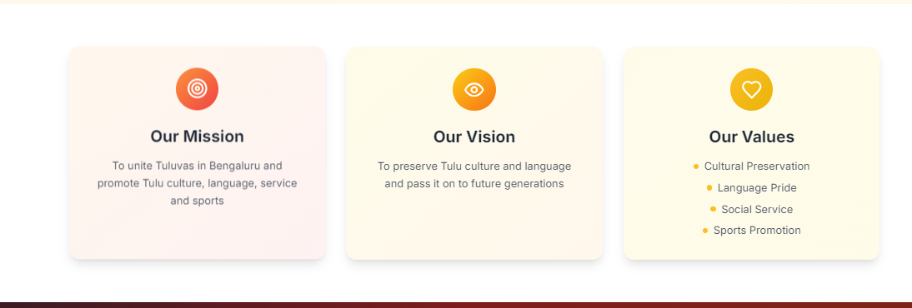
Please provide the content both in kannada and english.
Answer:
3.
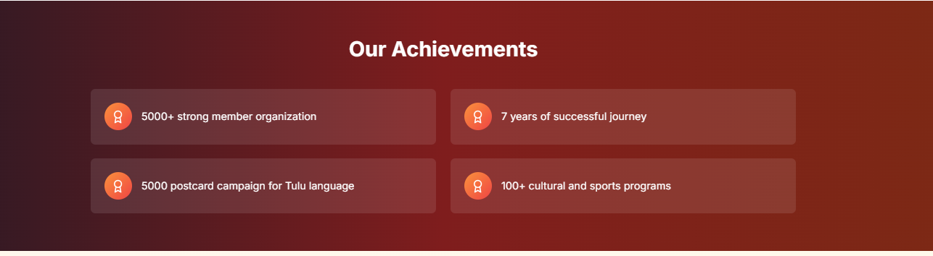
Please provide information on Achievments.
Answer:
4.
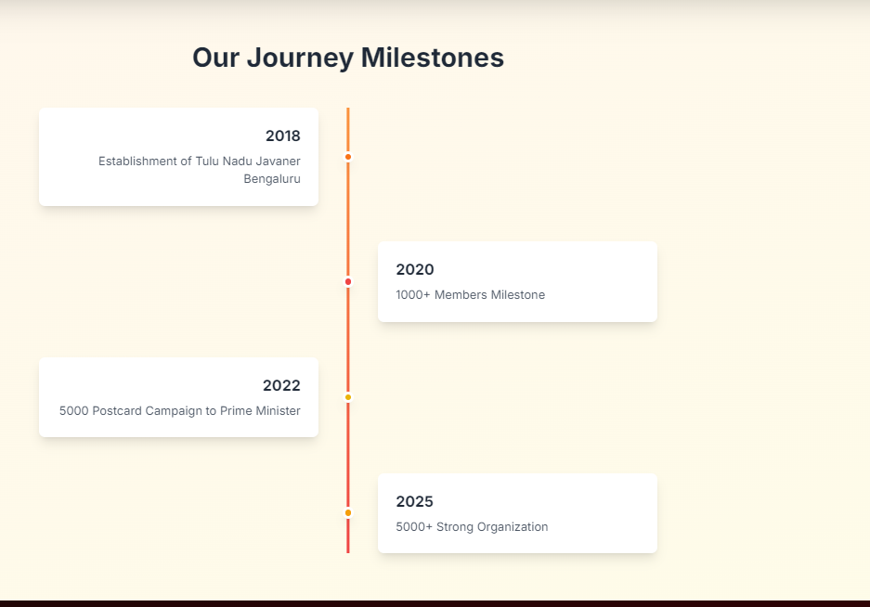
Please provide information both in English and Kannada.
Answer:
Services section

1.
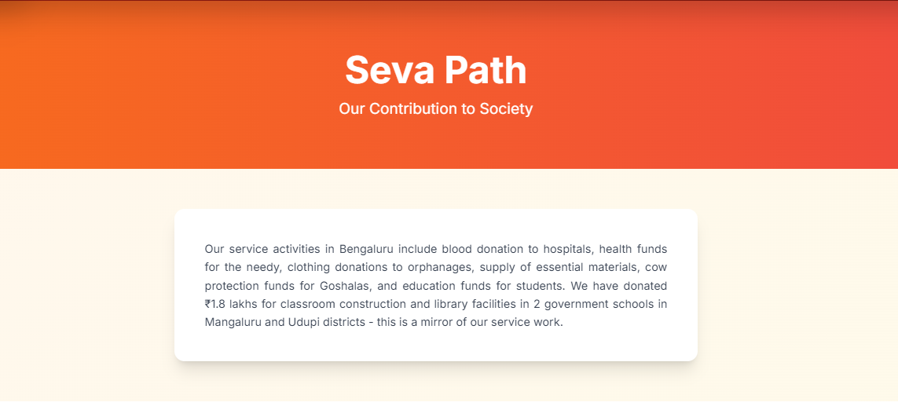
Please provide the information both in Kannada and English.
2.
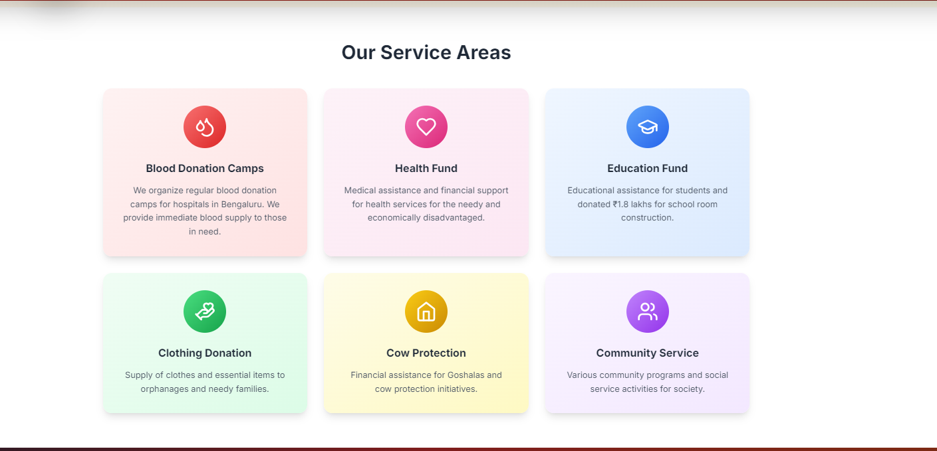
Please provide the information both kannada and english. If anything needs to update please add it.
Answer:
3.
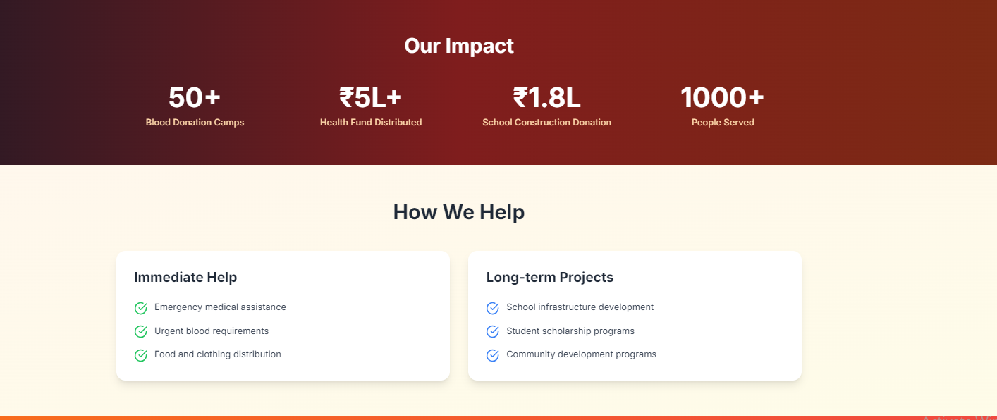
Please provide the exact information
Answer:

Contact Us section
1.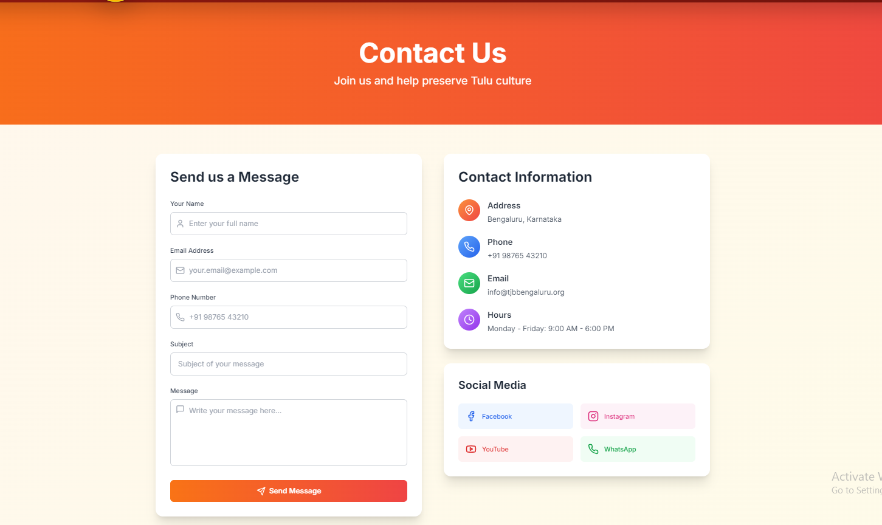
Please provide all the details including Google map link.
Answer:
Events Section
- Please check the events section in the website and let use know what information needs to added for the events.
Website link has been provided with this document.

